X and Y are fetched from the input SRAM (xyz_data_sram).
Z is not fetched from SRAM – it is generated inside the CORDIC pipeline.

Yes – the z_in fed into the CORDIC pipeline is hard‑wired to 0 for every operation (MAC, LV, HR, and also for the Soft‑Max exponent unit).

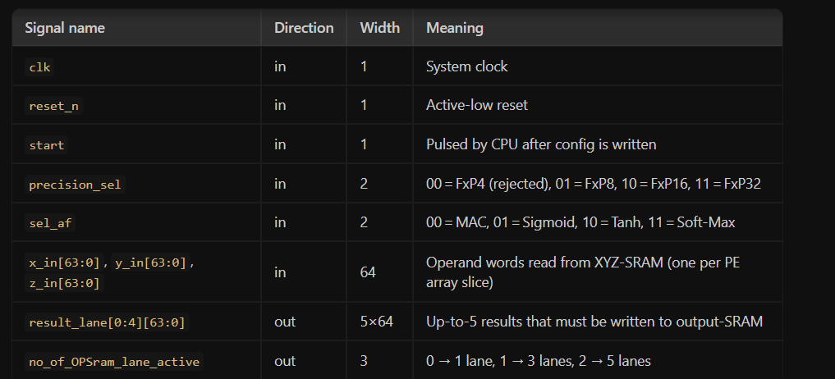

ok now what i decided is : (note: no_of_OPSram_lane_active this is generated by systolic array not by the cpu via axi)
i will use static with pre filled sram to make the accelerator with simd, dynamic precision, function, pipelined pe, axi lite to get start,precision,function from the cpu and after completing operations with all the data it sends back compl signal via axi back to cpu (so that cpucan configure the dma controller to get back the output data to main memory and maked dma to transfer next set of data and process repeats...), for each clk cycle our accelerator (not cpu , once cpu sends start,config signals itswoek is over and after accelerator completes everything the accelerator sends compl signal to cpu thats it) needs to generate no_of_OPSram_lane_active which is connected to Output_Sram. (i am gonna make this accelerator currently with static output_Sram,xyz_Sram and at the end i will connect his work to me)

now i am gonna tell my temate to blindly make xyz_data_sram input with 3 io connections x,y,z * 64 bits, address- all are controlled via DMA to store data on SRAM and make output_sram with configuring data write lanes (because number of datas to be written per clk cycle will change if its @clk 1 the pe00 will give output (1 data) @clk 2 pe-01,10,11 will give output (3 datas) @clk-3 pe-20,21,22,02,12 will give output (5 datas) so at max it can provide 5 datas so the output sram needs to have 5 data input lanes (so that 5 or 3 or 1 data can be written at 1 clk cycle) @clk 1 the accelerator gives signal no_of_OPSram_lane_active:-(
00- data input lane 0 only valid (pe-00 output)
01- data input lane 0,1,2 only valid ( pe-01,10,11 output)
10- data input lane 0,1,2,3,4 only valid ( pe-20,21,22,02,12 output)
then the sram should allocate the address accordingly:
pe-00 output @address1
pe-01 output @address2
pe-10 output @address3
pe-11 output @address4
pe-20 output @address5
pe-21 output @address6
pe-22 output @address7
pe-02 output @address8
pe-12 output @address9
again
pe-00 output @address10
pe-01 output @address11
this address should be allocated accordingly according to the no_of_OPSram_lane_active
) this signal is generated by accelerator according to its clk cycle, make DMA to transfer the data of output_sram to the cpu main memory iif cpu ask dma to do

so he needs to make configurable output_Sram,xyz_Sram, DMA to transfer main memory to xyz_Sram and DMA from output_Sram to main memory as per the cpu request (cpu-DMA,DMA-outputSram,DMA-mainmemory,DMA-xyz_sram communication is according to his wish or if possible u tell)...i am not gonna tell this accelerator part because it may confuse him

now tell me is my way of systolic array sram connection , flow is correct? and explain my work , explain his spec i need to provide him and the work indepth so that i will show him

